Step 1: Create Directories

powershell

Copy

Download

# Config Server

mkdir C:\data\cfg1, C:\data\cfg2, C:\data\cfg3

# Shard Servers (2 shards, 3 nodes each)

mkdir C:\data\shard1_1, C:\data\shard1_2, C:\data\shard1_3

mkdir C:\data\shard2_1, C:\data\shard2_2, C:\data\shard2_3

# Mongos router

mkdir C:\data\mongos

Step 2: Start Config Server Replica Set

Run in 3 separate PowerShell windows:

powershell

Copy

Download

# Config Server 1

mongod --configsvr --replSet configReplSet --port 27019 --dbpath C:\data\cfg1 --bind_ip localhost

# Config Server 2

mongod --configsvr --replSet configReplSet --port 27020 --dbpath C:\data\cfg2 --bind_ip localhost

# Config Server 3

mongod --configsvr --replSet configReplSet --port 27021 --dbpath C:\data\cfg3 --bind_ip localhost

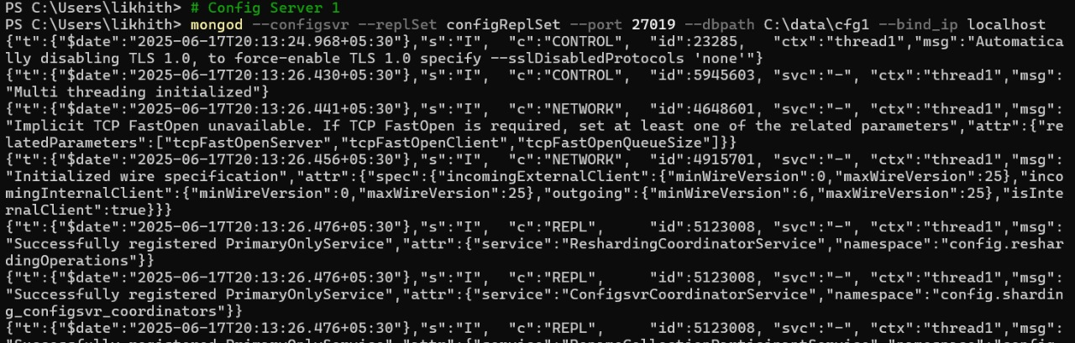

Initialize Shard 1:

powershell

Copy

Download

mongo --port 27022

javascript

Copy

Download

rs.initiate({

_id: "shard1ReplSet",

members: [

{ _id: 0, host: "localhost:27022" },

{ _id: 1, host: "localhost:27023" },

{ _id: 2, host: "localhost:27024" }

]

})

Shard 2 (3 nodes in separate PowerShell windows):

powershell

Copy

Download

# Shard2 Node1

mongod --shardsvr --replSet shard2ReplSet --port 27025 --dbpath C:\data\shard2_1 --bind_ip localhost

# Shard2 Node2

mongod --shardsvr --replSet shard2ReplSet --port 27026 --dbpath C:\data\shard2_2 --bind_ip localhost

# Shard2 Node3

mongod --shardsvr --replSet shard2ReplSet --port 27027 --dbpath C:\data\shard2_3 --bind_ip localhost

Initialize Shard 2:

powershell

Copy

Download

mongo --port 27025

javascript

Copy

Download

rs.initiate({

_id: "shard2ReplSet",

members: [

{ _id: 0, host: "localhost:27025" },

{ _id: 1, host: "localhost:27026" },

{ _id: 2, host: "localhost:27027" }

]

})

Step 4: Start Mongos Query Router

powershell

Copy

Download

mongos --configdb configReplSet/localhost:27019,localhost:27020,localhost:27021 --port 27018 --bind_ip localhost

Step 5: Configure Sharding

Connect to mongos:

powershell

Copy

Download

mongo --port 27018

Add shards to cluster:

javascript

Copy

Download

sh.addShard("shard1ReplSet/localhost:27022,localhost:27023,localhost:27024")

sh.addShard("shard2ReplSet/localhost:27025,localhost:27026,localhost:27027")

Step 6: Enable Sharding for a Database and Collection

javascript

Copy

Download

// Enable sharding for a database

sh.enableSharding("testDB")

// Shard a collection with hashed shard key

sh.shardCollection("testDB.testCollection", { "_id": "hashed" })

// Or with ranged sharding

sh.shardCollection("testDB.testCollection", { "userId": 1 })



